Autumn 23



We’re working hard to keep you well

Welcome to our Autumn newsletter!

Since our last newsletter we’ve been busy getting ready for the busy months ahead with increased winter pressures.

We have more trained vaccinators than ever to deliver your flu vaccines, including some of our care navigators who will be able to offer flu vaccines to patients who come into surgery, meaning you won’t have to wait for an appointment with a member of our nursing team!

We’ve expanded our enhanced clinical team and welcomed our Advanced Care Practitioner Andy to the practice. Andy’s appointments are bookable on the day for acute issues like chest infections, new lumps, vomiting and diarrhoea etc.

Thanks,

Dr Welsh, Dr Doddridge, Dr Edwards, Dr Tyagi and the Leadership Team



* 12883 patients are registered in the surgery.
* Between June – August there were 245 appointment DNA’s.
* 6464 prescriptions were issued.
* 184 Home Visits were carried out.
* Over 80% of patients said they would recommend us to their friends and family.

Each issue we release some data of what’s going on in practice, the figures will always be for the 3 months prior. Figures shown to the right are for June – August 2023.

Meet Our Practice Pharmacist!

**Meet Wes (Pictured with Dr Doddridge), Wes is our clinical pharmacist at the medical Centre. He has years of experience working in primary care and is a key member of our senior clinical team. Wes works with our GP’s, nurses and community pharmacists to manage medication and complete long term condition reviews. By having a clinical pharmacist in surgery, GP’s can focus their skills where they are most needed, for example diagnosing and treating patients with more complex conditions, this helps GP’s manage the demands on their time.**

**Opening Hours**

MONDAY 8AM - 6.30PM

TUESDAY 8AM - 6.30PM

WEDNESDAY 8AM - 6.30PM

THURSDAY 8AM - 6.30PM

FRIDAY 8AM - 6.30PM

SATURDAY CLOSED

SUNDAY CLOSED

Please note we offer extended access appointments, ask reception for more details.

**Dates for your Diary**

27th September…………………………………...Surgery closes at 1pm

30th September………………..….Walk in flu clinic 9am – 12 noon

25th October……………………………..…………….Surgery closes 1pm

31st October……………………………………………………..…Halloween

5th November…………………..…………..Guy Fawkes/Bonfire Night

29th November……………………………..…………Surgery closes 1pm

Please keep an eye on our website and Facebook page for any changes.

***Seasonal Flu Vaccines:***

We are due to receive our flu vaccines on 27thof September and have a planned walk-in flu clinic for adults aged 65+ on Saturday 30th September from 9am – 12 noon, this will be our first walk in flu clinic of the year, but we are hoping to offer others throughout the coming months.

We also have more trained vaccinators than ever to deliver your flu vaccines, including some of our care navigators who will be able to offer flu vaccines to patients who come into surgery, meaning you won’t have to wait for an appointment with a member of our nursing team!

Children’s Flu vaccine is offered in primary care for children aged 2 years until they start primary school, if your child is aged between 6 months and 2 years and has a long-term health condition that makes them at higher risk of catching flu, they’ll be offered a flu injection instead of the nasal spray.





***Online Access to Patient Records***

From November 2023 patients will be able to access more detailed information on their online medical record. Currently, your online record should include information like your current medication and allergies.

However, from November you should be able to access more information such as letters, test results and appointment notes.

To access this, you will need to sign up for online access to your medical record. This can be done by completing a form at reception.



*Covid 19 Vaccinations*

Unfortunately, we are not participating in the Covid 19 Autumn Booster vaccine campaign. The ways you can get a seasonal COVID – 19 vaccination are below:

* Booking an appointment online
* Booking an appointment on the NHS app
* Going to a walk in Covid 19 Vaccination site.

For more information, please contact 119.

* Stand far away from bonfires and fireworks.
* Only light one sparkler at a time and hold it at arm’s length.
* Don’t go near a firework after it has been lit.
* Keep a bucket of water ready for emergencies.

***Bonfire Night Safety***

Last year 999 received fewer calls than the year previous and it’s all thanks to you and the rest of the public. We hope you and your family have a great bonfire night however you celebrate. Follow our tips below to have a happy and safe bonfire night.

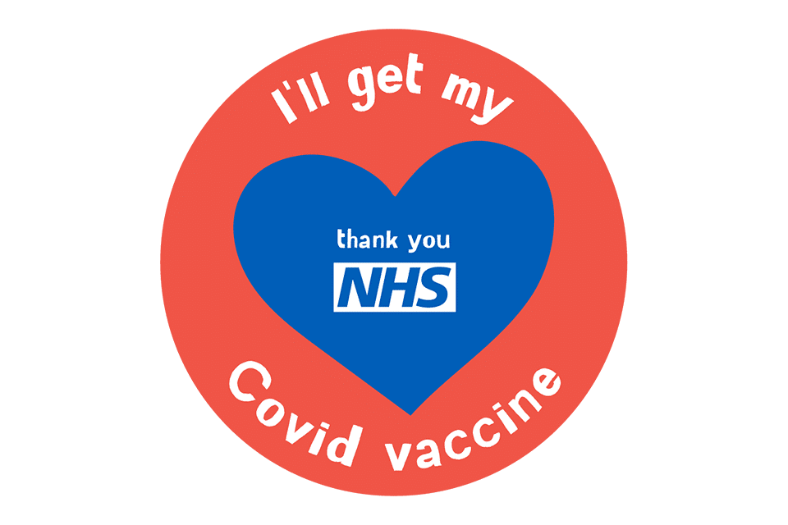

Our Primary Care Network – IGPC have rebranded, we think their new logo looks great! The primary Care Network is a collaborative network of multiple GP Practices, and the team consists of Social Prescribers, Pharmacists, Care Co Ordinator’s and other Health professionals to work with GP Practices to provide many different patient services.